ROSS-SHIRE WOMENS AID  Sponsor Form  Danceathon  Saturday 18th February  12.00 – 8.000pm | 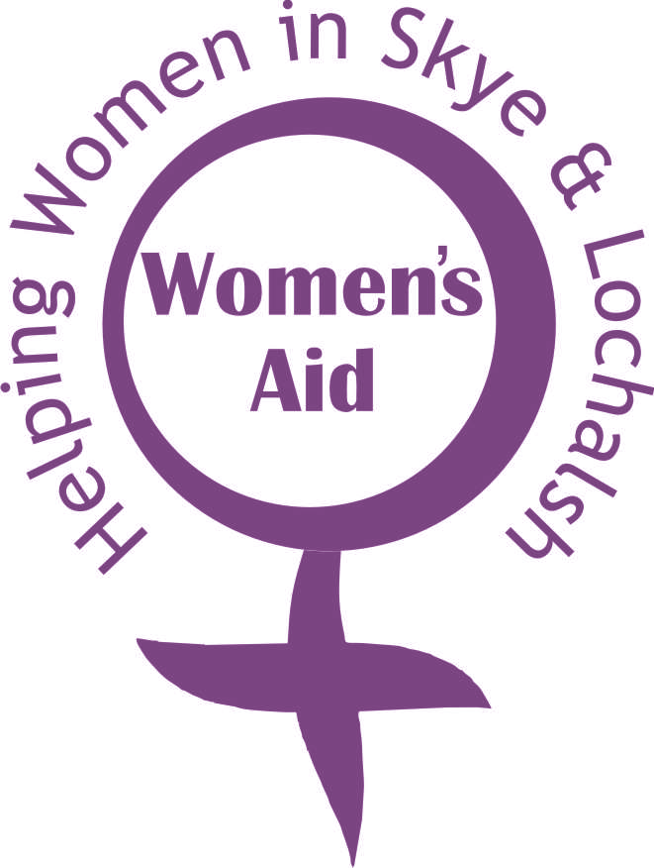
Entrant’s Name: _____________________________________
Address: _____________________________________
___________________ Postcode: _____________
 | Name of Sponsor | Address | Donation | Gift Aid
1
2
3
4
5
6
7
8
9
10
11
12
13
14
15
16
17
18

Total This Page £____________
If you are a UK taxpayer, the value of your donation can increase by 25% under the Gift Aid Scheme at no extra cost to you! To qualify for Gift Aid, you must have paid an amount of income tax and/or capital gains tax for each tax year (6 April one year to 5 April the next) that is at least equal to the amount of tax that Ross-shire omen’s Aid reclaim on your donations for that tax year. Please tick the box above to join the Gift Aid Scheme
 | Name of Sponsor | Address | Donation | Gift Aid
19
20
21
22
23
24
25
26
27
28
29
30
31
32
33
34
35
36
37
38
39
40
41
42
43
44
45
46
47
48
49
50
TOTAL SPONSORSHIP RECEIVED |  |  | £

If you are a UK taxpayer, the value of your donation can increase by 25% under the Gift Aid Scheme at no extra cost to you! To qualify for Gift Aid, you must have paid an amount of income tax and/or capitail gains tax for each tax year (6 April one year to 5 April the next) that is at least equal to the amount of tax that Ross-shire Women’s Aid will reclaim on your donations for that year. Please tick the box above to join the Gift Aid Scheme
Or got to http://uk.virginmoneygiving.com/charity-web/charity/displayEventDetails.action?eventId=11840&charityId=1004010&invocation=don0060
ROSS-SHIRE WOMEN;S AID IS A CHARITY REGISTERED IN SCOTLAND NO SC008514

